18.49: Ice crystals will form if 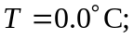 using this in the given relation for temperature as a function of altitude gives 